Week-08-Sorting Algorithms-Bubble and Selection

Week 08-01-practice session coding

Reg no : 241801291

Name : TARRUN.B

Q1)

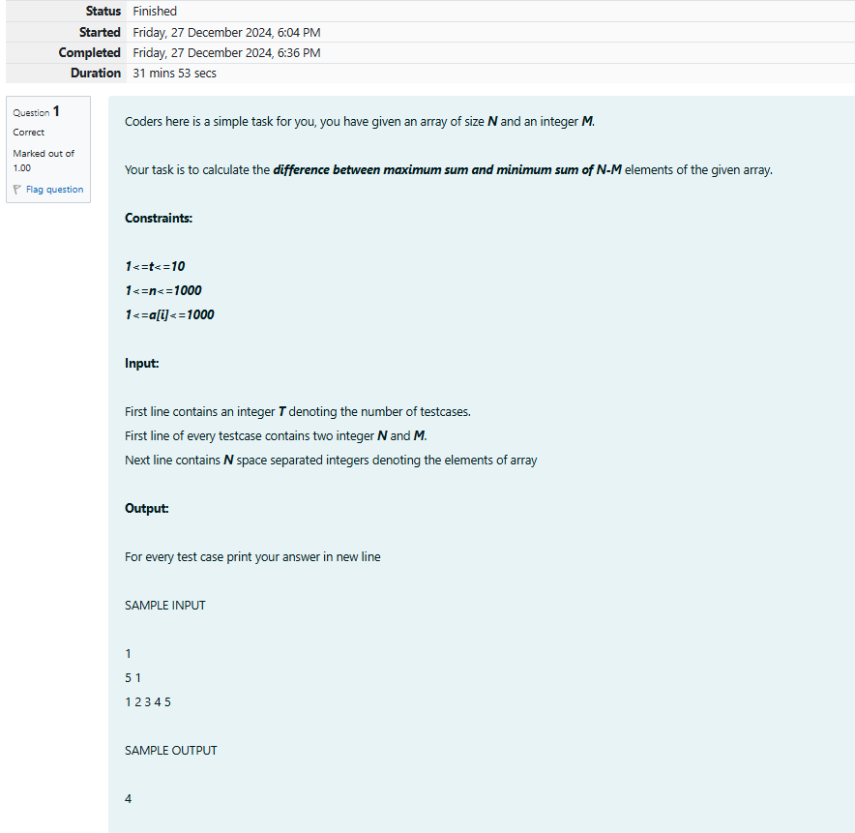

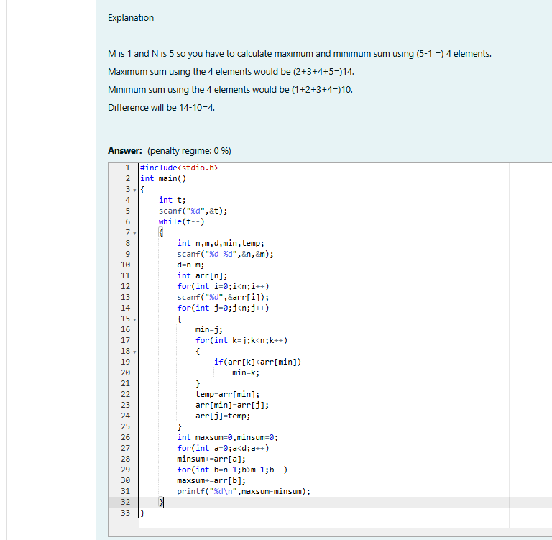

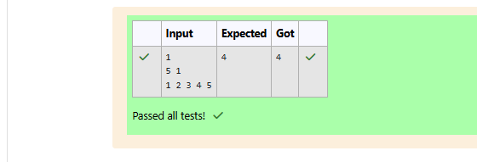

Week 08-01-practice session coding

Reg no : 241801291

Name : TARRUN.B

Q2)

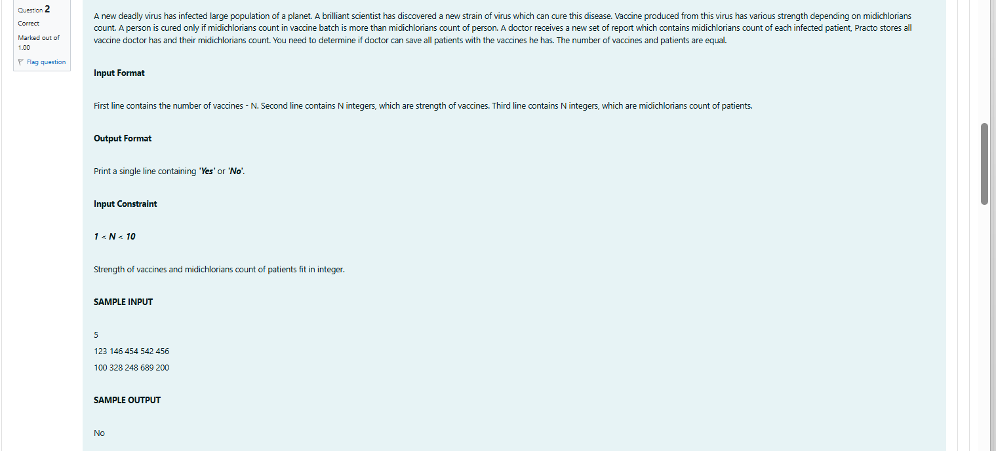

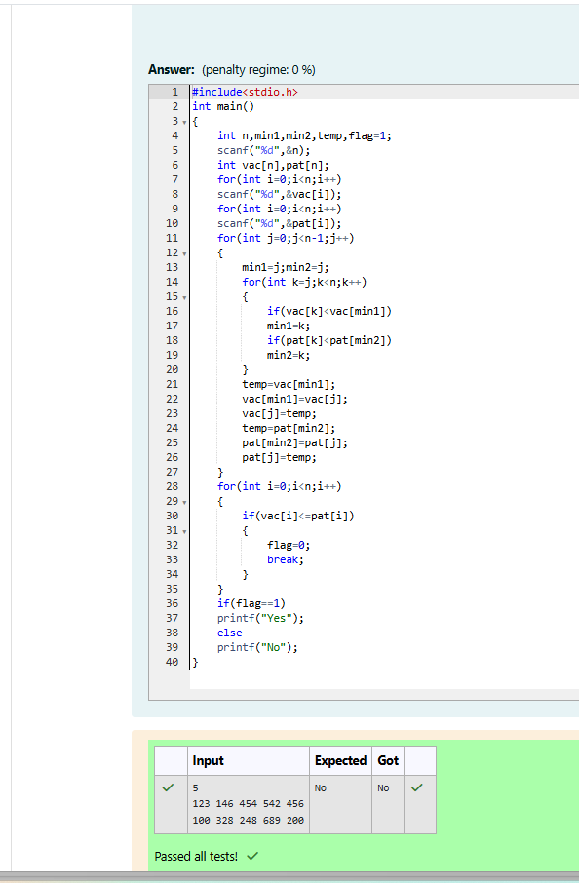

Week 08-01-practice session coding

Reg no : 241801291

Name : TARRUN.B

Q3)

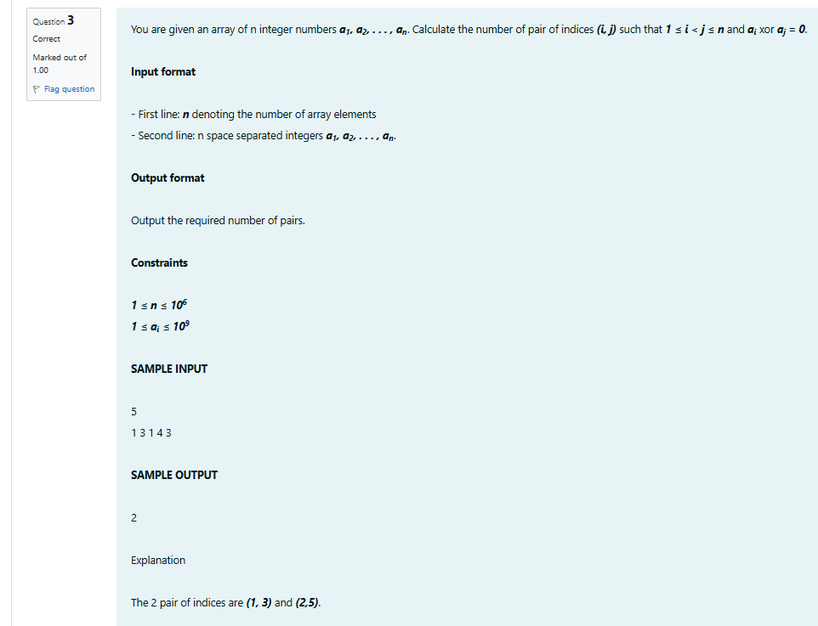

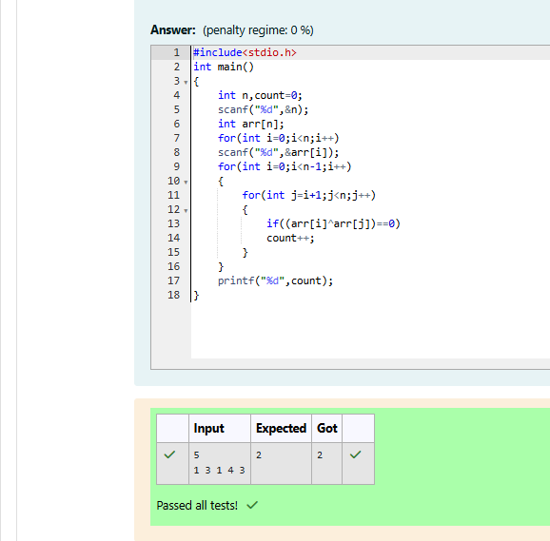

Week 08-01-practice session coding

Reg no : 241801291

Name : TARRUN.B

Q4)

